| **Test Name** | Pump controller offline alarm |
| --- | --- |
| **Use Case Tested:** | Raise alarm for missing status message |
| **Test Description:** | This test verifies the business rules can detect when the pump controller seems to be offline due to the interval between status messages. |
| **Pre-conditions** | * None. |
| **Post-conditions** | * None. |
| **Notes:** | This test can be done with either the simulator or a Feather. |

|  | **TEST STEP** | **EXPECTED TEST RESULTS** |
| --- | --- | --- |
|  | Send a status message from the pump controller. | * No visible results. |
|  | Unplug the pump controller or close the simulator. | * No visible results. |
|  | Wait up to 25 minutes. | * After about 20 minutes a “Pump Controller Offline” alarm will be raised on the dashboard. |
|  | Start the simulator/plug in the Feather and send a status message. | * The “Pump Controller Offline” alarm will be cleared. |

|  |  |  |  |  |  |
| --- | --- | --- | --- | --- | --- |
| **Test Data Table** | | | | | |
|  | **1** | **2** | **3** | **4** | **5** |
| [Data field 1] | [data set 1 input value for field 1] |  |  |  |  |
| [Data field 2] | [data set 1 input value for field 2] |  |  |  |  |
| [Data field 3] | [data set 1 input value for field 3] |  |  |  |  |

**Results**

11/09/2020

Success.

Step 3.

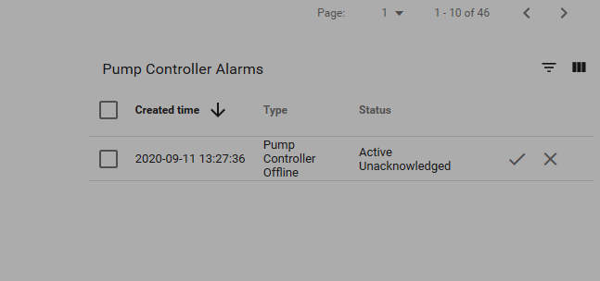

Step 4.

